**EXPOSITION AND BENEDICTION**

**OF THE BLESSED SACRAMENT**

EXPOSITION OF THE BLESSED SACRAMENT

*The Blessed Sacrament is taken out of the tabernacle and placed in the monstrance and exposed to the view of the people* ***(Exposition****). All sing a Hymn to the Blessed Sacrament.*

*Opening Hymn O* SALUTARIS

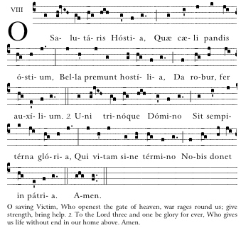

|  |  |  |
| --- | --- | --- |
| *O Saving Victim, opening wide*  *The gate of heav’n to man below;*  *Our foes press on from every side;*  *Thine aid supply, Thy strength bestow.* |  | *To thy great name be endless praise,*  *Immortal Godhead, One in Three;*  *O grant us endless length of days*  *In our true native land with Thee.* |

Hymn in Honor of the Blessed Sacrament

AVE VERUM CORPUS

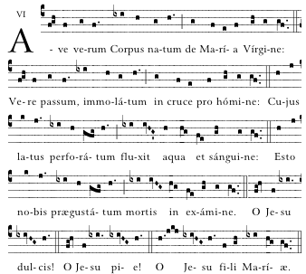

|  |
| --- |
| *Hail, true Body, born of Mary the Virgin; truly suffering, sacrificed on the cross for man; from Whose pierced side flowed water and blood. Be to us a foretaste at death’s trial, O sweet Jesus, O loving Jesus, O Jesus Son of Mary.* |

*After a period of meditation and reflection the celebrant goes to the altar, genuflects, and kneels. The* Tantum ergo*, is sung:*

BENEDICTION OF THE BLESSED SACRAMENT

TANTUM ERGO

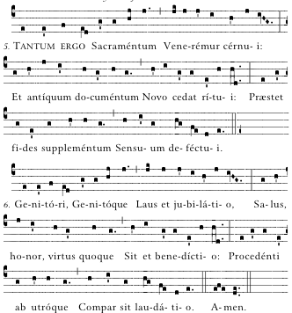

2.

1



|  |  |  |
| --- | --- | --- |
| *Therefore we, before him bending,*  *This great Sacrament revere;*  *Types and shadows have their ending,*  *For the new rite is here;*  *Faith, our outward sense befriending,*  *Makes the inward vision clear.* |  | *Glory let us give, and blessing*  *To the Father and the Son;*  *Honor, might, and praise addressing,*  *While eternal ages run;*  *Ever too his love confessing,*  *Who from both, with both is one. Amen.* |

|  |  |  |
| --- | --- | --- |
| Priest: | Panem de cælo præstitísti eis. (Allelúia.) | |
|  |  | *You gavest them Bread from heaven. (Alleluia.).* |
| All: | **Omne delectaméntum in se habéntem. (Allelúia.)** | |
|  |  | ***Containing within itself all sweetness. (Alleluia.)*** |
| Priest: | Orémus: Deus, qui nobis sub Sacraménto mirábili passiónis tuæ memóriam reliquísti: *†* tríbue, quaésumus, ita nos córporis et sánguinis tui sacra mystéria venerári; ut redemptiónis tuæ fructum in nobis júgiter sentiámus. Qui vivis et regnas in saécula sæculórum. | |
|  |  | *Let us pray. Lord Jesus Christ, you gave us the Eucharist as the memorial of your suffering and death. May our worship of this sacrament of your body and blood, help us to experience the salvation won for us and the peace of the kingdom, where you live with the Father and the Holy Spirit, one God, for ever and ever.* |
| All: | **Amen.** | |

*The celebrant will then bless all present with the Eucharist.*

*The priest descends the steps and while kneeling recites or all sing The Divine Praises.*

The Divine Praises

*Priest or cantor (Pr) and All alternate*

|  |  |
| --- | --- |
| *1*  *Pr*  *All*  *Pr*  *All*  *Pr*  *All*  *Pr* |  |

|  |  |
| --- | --- |
| *All*  *Pr*  *All*  *Pr*  *All*  *All* |  |

|  |
| --- |
| Blessed be God.  Blessed be his Holy Name.  Blessed be Jesus Christ, true God and true Man.  Blessed be the Name of Jesus.  Blessed be his most Sacred Heart.  Blessed be his most Precious Blood.  Blessed be Jesus in the most holy Sacrament of the Altar.  Blessed be the Holy Spirit, the Paraclete.  Blessed be the great Mother of God, Mary most holy.  Blessed be her holy and Immaculate Conception.  Blessed be her glorious Assumption.  Blessed be the name of Mary, Virgin and Mother.  Blessed be St. Joseph, her most chaste spouse.  Blessed be God in his Angels and in his Saints. |

RESPOSITION

*The priest replaces the Blessed Sacrament in the tabernacle. When the doors of the tabernacle have been closed the congregation rises and sings the Adoremus in aeternum.*

ADOREMUS IN AETERNUM

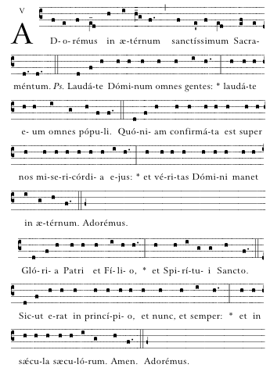

**

|  |
| --- |
| *Let us worship forever the most holy Sacrament. Ps. O praise the Lord, all ye nations: praise Him, all ye people. For His mercy is confirmed upon us: and the truth of the Lord remaineth for ever. Glory be to the Father, and to the Son, and to the Holy Spirit: as it was in the beginning, is now, and ever shall be, world without end. Amen.* |

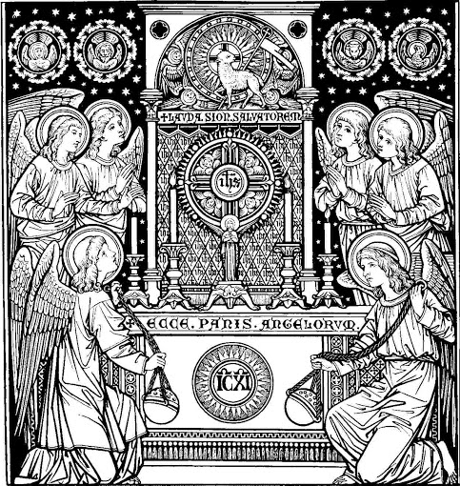

-----------

This booklet was prepared for parish/chapel use (January 2014)

Music for chants from from *Parish Book of Chant* (editor Richard Rice) © 2012 used with permission from The Church Music Association of America. Music for Divine Praises typset from arrangement provided by St. Cecilia’s Abbey, UK.